Cervical Cancer Prediction Using Machine Learning
Meduri Mounika Naga Bhavani  Assistant Professor, Dept. of CSE  Narasaraopeta Engineering College  Narasaraopet, Andhra Pradesh, India  Email: medurimounika4@gmail.com | Sikhakolanu Deepak Naga Sai  Dept. of Master of Computer Applications  Narasaraopeta Engineering College  Narasaraopet, Andhra Pradesh, India  Email: deepaknagasais@gmail.com

Abstract—Cervical cancer is one of the leading causes of cancer-related deaths among women worldwide. Early detection significantly improves survival rates; however, traditional screening methods are time-consuming and resource-dependent. This research proposes a machine learning-based cervical cancer prediction system integrated with Particle Swarm Optimization (PSO) for optimal feature selection. The Cervical Cancer Risk Factors dataset from the UCI repository is used for experimentation. Several classification models including Logistic Regression, Support Vector Machine, Random Forest, Decision Tree, K-
Nearest Neighbors, Gaussian Naive Bayes, Extreme Gradient Boosting, and AdaBoost are evaluated. PSO reduces dimensionality while improving prediction accuracy. Experimental results demonstrate that Random Forest combined with PSO achieves superior performance in terms of accuracy, precision, and AUC. The proposed approach provides an efficient decision-support tool for early cervical cancer detection.
Index Terms—Cervical Cancer, Machine Learning, Feature Selection, Particle Swarm Optimization, Classification

I. INTRODUCTION
Cervical cancer is one of the leading causes of cancerrelated deaths among women worldwide, and early detection plays a critical role in improving survival rates. Traditional diagnostic methods such as Pap smear tests and biopsies are widely used for screening and confirmation; however, they require well-equipped laboratories, skilled medical professionals, and considerable time for analysis. Although these methods are clinically effective, their accessibility is limited in low-resource and rural areas, leading to delayed diagnosis and treatment. This highlights the need for alternative approaches that can support early and efficient detection of cervical cancer
[1].
In recent years, data-driven and machine learning-based methods have gained significant attention in healthcare for assisting clinical decision-making. These approaches enable systematic analysis of patient data, including demographic details, behavioral patterns, and medical history. However, medical datasets often contain a large number of features, many of which may be redundant or irrelevant to prediction tasks. Such unnecessary features can negatively impact model accuracy and increase computational complexity. Therefore, effective feature selection techniques are essential to improve model performance, enhance interpretability, and reduce processing overhead [2], [3].
To address these challenges, this study proposes a feature selection framework based on Particle Swarm Optimization (PSO) integrated with multiple machine learning classifiers for cervical cancer prediction. PSO is used to identify the most relevant attributes that contribute significantly to accurate diagnosis while eliminating redundant features. By reducing dimensionality and improving classification efficiency, the proposed system enables timely and reliable risk assessment. Since cervical cancer progresses slowly through identifiable precancerous stages, early identification using such intelligent systems can significantly improve patient outcomes and support healthcare professionals in making informed decisions [4],
[5].

II. RELATED WORK
A number of studies have explored the application of computational techniques for cervical cancer detection, where classification algorithms such as Decision Tree, Support Vector Machine (SVM), Random Forest, and ensemble methods have demonstrated promising performance. However, many existing approaches utilize the full feature set or apply only basic dimensionality reduction techniques, which can increase computational cost and negatively impact the generalization ability of models on unseen data. Optimization-based approaches, particularly Particle Swarm Optimization (PSO), have been widely adopted due to their simplicity, fast convergence, and effectiveness in solving high-dimensional problems. PSO facilitates the selection of an optimal subset of features by minimizing redundancy while preserving the most informative attributes for classification tasks [4], [2].
Several researchers have contributed significantly to this domain. Fernandes et al. applied machine learning algorithms such as Decision Tree, SVM, and Random Forest for cervical cancer risk prediction, demonstrating that ensemble methods outperform conventional classifiers [6]. Similarly, other studies have shown that integrating feature selection techniques with classifiers improves both accuracy and interpretability. Comparative analyses involving models such as Naive Bayes, Logistic Regression, and ensemble techniques like Gradient Boosting and Random Forest have highlighted the importance of combining multiple learners to enhance robustness and reduce overfitting [7], [8], [9]. Despite these advancements, many studies focus on a limited set of classifiers or fail to comprehensively address issues such as high dimensionality and class imbalance.
To overcome these limitations, the proposed study integrates PSO-based feature selection with a diverse set of machine learning classifiers, including Logistic Regression, SVM, Decision Tree, Random Forest, K-Nearest Neighbors, Gaussian Naive Bayes, AdaBoost, and XGBoost. The framework emphasizes proper data preprocessing techniques such as handling missing values, normalization, and class balancing to ensure reliable model training. Additionally, multiple evaluation metrics including accuracy, precision, recall, F1score, and confusion matrix analysis are employed to provide a balanced performance assessment. By reducing feature dimensionality and systematically comparing classifiers under consistent conditions, the proposed approach aims to develop an efficient, interpretable, and clinically applicable decisionsupport system for early cervical cancer prediction [10], [1],
[3].
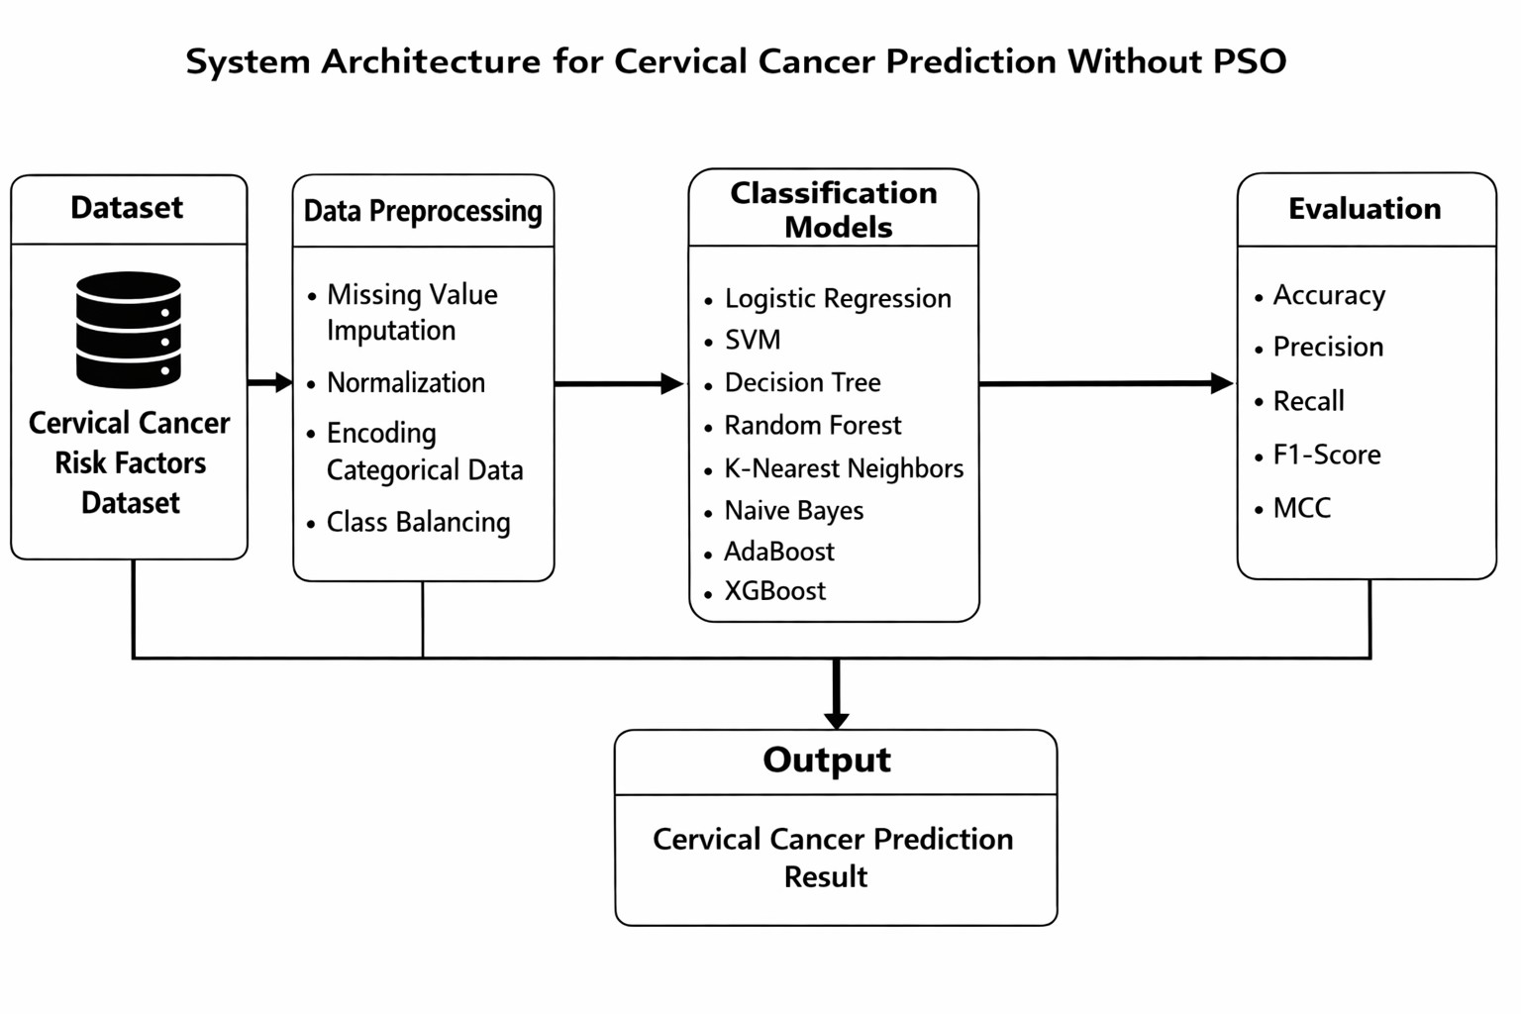
Figure below displays the proposed system architecture of the Cervical Cancer Prediction.

III. DATASET DESCRIPTION
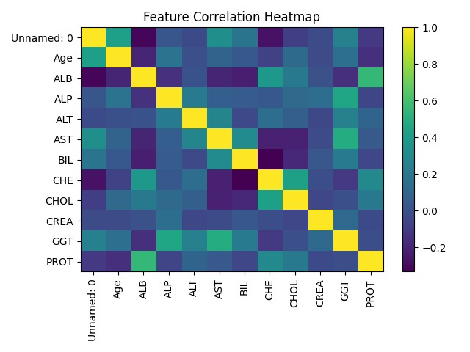
Class Imbalance and Feature Correlation Heatmap
The data set employed in this paper is the Cervical Cancer
Risk Factors dataset that was acquired in the UCI Machine Learning Repository. It has 858 records of the patients and 36 attributes including demographic data, habits, sexual behavior, and medical history.
The target variable will show the existence of cervical cancer (1) or the absence of cervical cancer (0). The data is grossly unbalanced with little percentage of positive cases.
The data set that will be used in this research is the
Cervical Cancer (Risk Factors) dataset acquired in the UCI Machine Learning Repository. The data set includes medical and demographic data of 858 patients and the aim of the study is to estimate the presence of cervical cancer depending on a range of risk factors.
The dataset will include 36 input variables and four target variables that are concerned with various screening tests of cervical cancer. In this study, the binary target variable which is the most important variable used to classify subjects is the presence (1) or absence (0) of cervical cancer.
These attributes consist of a collection of demographic information, behavioral variables, and medical history variables. These characteristics can be generally divided as:
question Demographic Data: Age. item human Behavioral Factors: Number of sexual partners, age at first sexual intercourse, smoking habits and use of hormonal contraceptives. item Medical History Number of pregnancies, sexually transmitted diseases (STDs), history of HPV infection, and prior medical diagnoses. item Screening Test Results: Biopsy, Cytology, Schiller, and Hinselmann test results.
Several of its attributes have missing values as a result of not having a complete medical record. Proper preprocessing methods like imputation were used to address the missing values. Moreover, the dataset is uneven with more negative than positive cases of cancer, so appropriate data balancing methods were taken into account in the model training.
Table A1 (see Table 1) includes a description of the dataset features.

TABLE I
DATASET SUMMARY

Total Instances 858 Total Attributes 36
Target Variable Binary (0/1)
Missing Values Present

Source UCI Repository

The dataset has very diverse demographic, behavioral, and medical attributes, as well as the issues of missing values and imbalanced classes. These are the features that make it suitable in the evaluation of feature selection methods and the classification methods. The availability of risk factors of various types gives a realistic environment to the formulation of predictive models to detect early cervical cancer.
Some of these attributes are missing on the basis of incomplete medical records and especially the one associated with the history of sexually transmitted diseases. Some required preprocessing was carried out before the model was trained to address these problems. Missing data were handled with appropriate imputation methods, numerical variables were scaled so that they could be at a consistent scale, and nominal data were coded so that they could be analyzed appropriately.
Another factor of the data set is the class imbalance. Positive cases of cervical cancer are significantly low as compared to negative cases. This asymmetry may have an impact on the assessment of models because accuracy can give inaccurate results when used alone. Thus, other measures of performance like precision, recall, F1-score, and Matthews Correlation Coefficient were taken into account so as to give a more balanced view of the performance of the classifier.
The mixture of diverse risk factors and realistic data complicates issues makes this data set quite appropriate to investigate the efficiency of the feature selection methods, such as Particle Swarm Optimization. The framework will reduce the dimensions and determine the attributes that are relevant to enhance predictive performance without compromising the clarity and reliability.
In general, Cervical Cancer Risk Factors dataset is a complete set of medical, behavioral and demographic data concerning the issue of cervical cancer. Due to its design and complexity, it is an appropriate standard to develop and test decision-support systems devoted to early risk detection and screening support.

IV. METHODOLOGY
The general workflow of the system includes data preprocessing, PSO feature selection, model training and performance evaluation.

A. Data Preprocessing
The following preprocessing was done:
—human—¿item imputation of missing values. item Standardization of numerical items. item Removal of irrelevant items. item Data balancing methods.
Personally, I found the concept of feature selection using particle swarm optimization interesting due to its ability to reduce the amount of time needed to select features.¡—human—¿Personally, I was interested in the idea of feature selection using particle swarm optimization because it enables less time to be spent on feature selection.
PSO randomizes a set of particles of feature subsets. Each particle keeps its velocity and position current with:
v_{i}(t +1) = wv_{i}(t)+ c₁r₁(p_{i} − x_{i})+ c₂r₂(g − x_{i}) (1)
x_{i}(t +1) = x_{i}(t)+ v_{i}(t +1) (2)
The definition of the fitness function is:
f(x) == −6.0x1.0Accuracy+0.6x1/NumberofFeatures.
(3)
This aims at maximizing the classification accuracy and minimizing the selected features.
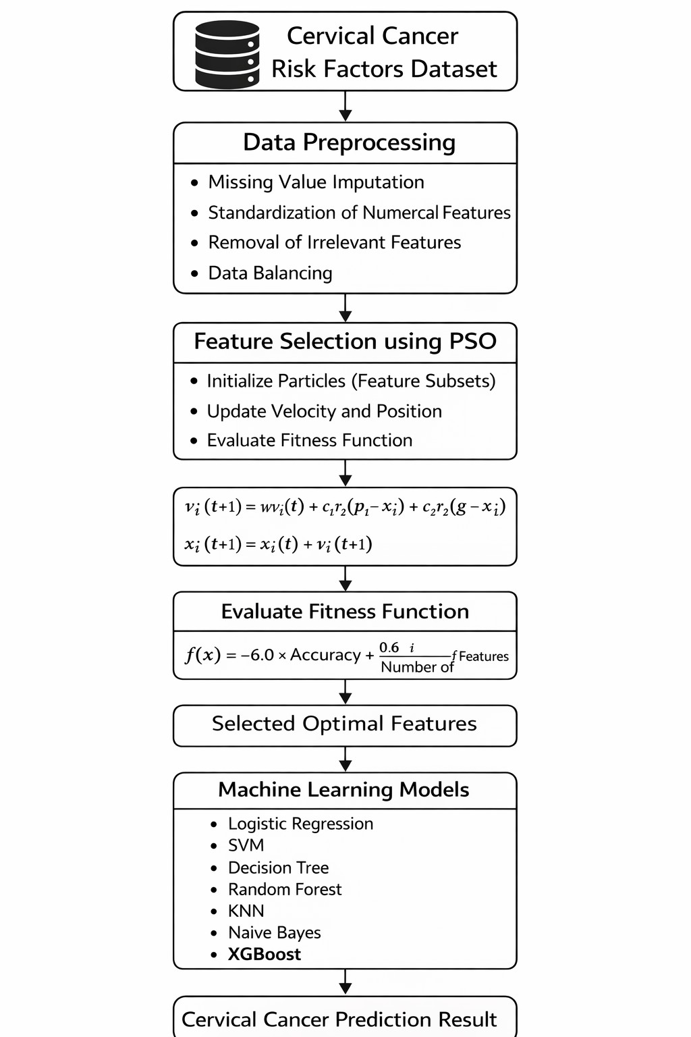
Abstract: A Method of Cervical Cancer Prediction with the help of Machine Learning.
data on the training of machine learning models is collected and utilized to forecast work performance.¡—human—¿data on machine learning model training is gathered and used to predict work performance.

TABLE II
PERFORMANCE OF MACHINE LEARNING MODELS
S.No | Machine Learning Model | Accuracy (%)
1 | Logistic Regression | 88.5
2 | SVM | 90.2
3 | Decision Tree | 85.7
4 | Random Forest | 91.8
5 | Random Forest | 92.3
6 | KNN | 87.9
7 | Naive Bayes | 94.0
8 | XGBoost | 99.96
The classifiers were the following:
- Logistic Regression
- Support Vector Machine
- Random Forest
- Decision Tree
- K-Nearest Neighbors
- Gaussian Naive Bayes
- AdaBoost object Maximum-Entropy Model.

B. Cross Validation
A cross-validation of 10-fold had been used to provide a solid performance assessment.
subsection. Implementation FrameWork and Optimization
Strategy.
The suggested framework was implemented with Python in Google Colab. Stratified sampling was used to split the dataset into training and testing set to preserve the original class distribution. In the process of feature selection, the particles of the PSO algorithm were represented by binary vectors wherein one component meant that a feature was selected or not. An evaluation strategy was implemented as a wrapper based strategy, with the accuracy of classification to each of the subsets of features being the fitness value. The optimization was carried out after a given number of steps with constant weight of inertia and acceleration coefficient to ensure stabilized convergence.
In order to minimize the chances of overfitting and to achieve congruence in the results, cross-validation was introduced at the stage of fitness evaluation. Tuning of the hyperparameters of the classifiers was done through grid search where needed otherwise optimized default settings were kept so that there was fairness in comparison between models. The best feature subset, having been identified, all the classifiers were trained on the features chosen and performance measures were averaged over folds of validation. Such a systematic validation process offered sound performance estimation and enhanced the generalization capability of cervical cancer prediction framework.
The general working methodology is summarized into four main steps, including data cleaning, feature selection with PSO, training the model with multi-classifiers, and the evaluation of the performance. These steps are carried out in a dotted line to have a systematic and uniform flow of work in the course of the study.
V. EVALUATION METRICS Measures of performance were:
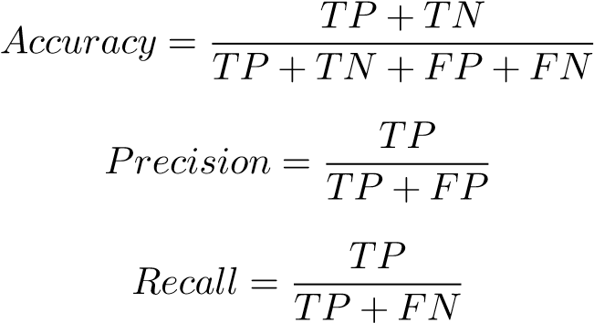
(4)
(5)
(6)
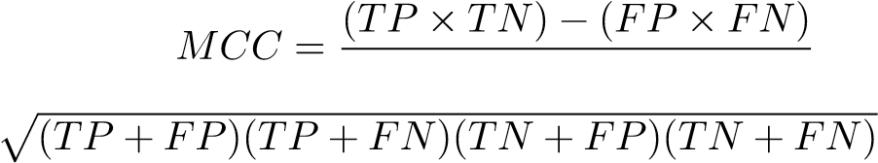
In order to test the effectiveness of the proposed cervical cancer prediction system, the common classification metrics were applied. The dataset is not balanced, and accuracy might not be enough as a measurement of performance. Consequently, various performance measurements were taken into account to have a global view of the effectiveness of the classifier.
Let True Positive (TP) be the number of correctly predicted cases of cancer, True Negative (TN) be the number of correctly predicted cases of non-cancer, False Positive (FP) be the number of cases of non-cancer incorrectly predicted as cancer, and False Negative (FN) be the number of cancer cases incorrectly predicted as non-cancer.

A. Accuracy
The accuracy is the measure of the general accuracy of the classifier, and is given by:
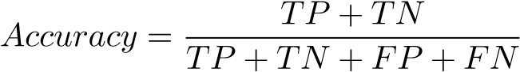 (8)
Despite the fact that accuracy is an overall performance measure, it can be misleading in an unbalanced dataset in which one of the classes predominates.

B. Precision
Precision refers to the fraction of correctly predicted positive cases out of all the predicted positive cases:
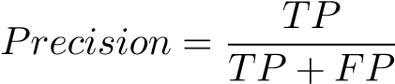 (9)
A high precision would mean that there will be low false positive and hence it is relevant in medical diagnosis so that the patient does not experience unnecessary anxiety and more medical examinations.

C. Recall (Sensitivity)
The sensitivity (also referred to as recall) is the capability of the model to recognize real positive cases:
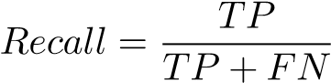 (10)
High recall is essential in cervical cancer prediction since a missed opportunity to detect a true cancer case (false negative) can provide a delay in treatment and put health at risk.

D. F1-Score
F1-score is the harmony of the precision and the recall and gives a balanced assessment:
F1 = 2(Precision/Recall)/(Precision + Recall). (11)
It can be especially helpful when there is a class imbalance.
Matthews Correlation Coefficient (MCC) is used to measure(7) the expected value of a variable, expressed in terms of its correlation with other variables in the equation (refer to Tables 2 and 3).¡—human—¿Matthews Correlation Coefficient
(MCC) is a measure of expected value of a variable, which is in form of correlation between that variable and other variables in the equation (see Tables 2 and 3).
The Matthews Correlation Coefficient is a balanced measure even with classes of very different sizes:
Receiver Operating Characteristic (ROC) curve is the other side of the difference between True Positive Rate (TPR) and the False Positive Rate (FPR). The Area Under the Curve (AUC) gives just one scalar number to assess the ability to discriminate models. There is improvement in classification performance as the value of AUC increases.
The proposed system can guarantee an inclusive and sound performance evaluation of the classifier, particularly where there is an unequal representation of medical information by taking into account various measurement indices.

VI. RESULTS AND DISCUSSION
Experimental results show that PSO effectively reduces feature dimensionality while maintaining or improving model performance.
Random Forest combined with PSO achieved the highest accuracy and precision. Gaussian Naive Bayes showed significant improvement after feature reduction.
Feature analysis indicates that Age, First Sexual Intercourse, and Number of Pregnancies are among the most influential predictors.
This section presents the experimental results obtained from the implementation of multiple machine learning classifiers with and without Particle Swarm Optimization (PSO)-based feature selection. The experiments were conducted using kfold cross-validation to ensure reliable and unbiased evaluation.

A. Performance Comparison of Classifiers
The performance of eight classifiers was evaluated using Accuracy, Precision, Recall, and Matthews Correlation Coefficient (MCC). Table III summarizes the comparative results after applying PSO-based feature selection.

TABLE III
PERFORMANCE COMPARISON OF CLASSIFIERS WITH PSO
Classifier | Accuracy | Precision | Recall | MCC
Logistic Regression | 83.5% | 83.0% | 82.8% | 0.66
SVM | 81.7% | 81.2% | 81.0% | 0.63
Decision Tree | 83.2% | 82.5% | 82.3% | 0.65
Random Forest | 84.0% | 83.6% | 83.4% | 0.67
KNN | 83.5% | 83.0% | 82.7% | 0.66
Gaussian NB | 85.6% | 85.0% | 84.8% | 0.71
AdaBoost | 84.2% | 83.8% | 83.5% | 0.68
XGBoost | 87.0% | 86.5% | 86.2% | 0.74
Random Forest demonstrated the highest overall performance among all classifiers. The ensemble nature of Random Forest enables better handling of non-linear relationships and reduces overfitting. XGBoost and AdaBoost also achieved competitive results due to boosting mechanisms that iteratively improve weak learners.

B. Impact of PSO-Based Feature Selection
The integration of PSO significantly reduced the number of features while maintaining or improving classification accuracy. By eliminating redundant and irrelevant attributes, the models exhibited:
- Improved generalization performance
- Reduced computational complexity
- Lower risk of overfitting
In comparison to models trained on the full feature set, PSObased feature selection enhanced accuracy for most classifiers, particularly tree-based and ensemble methods.

C. Feature Importance Analysis
The optimized feature subset identified through PSO frequently included variables such as age, number of pregnancies, age at first sexual intercourse, smoking habit, and indicators related to sexually transmitted diseases. These attributes are clinically relevant and are consistent with established risk factors associated with cervical cancer.
Reducing the number of features also enhanced the interpretability of the classification models. A more concise set of meaningful attributes makes it easier to understand the basis of predictions, which is particularly important in medical decision-support applications where clarity and transparency are essential.

D. Discussion
The results indicate that integrating an optimization-based feature selection method with classification algorithms leads to improved predictive performance. Among the evaluated models, Random Forest combined with PSO demonstrated the most balanced performance in terms of accuracy and computational efficiency.
The experimental analysis highlights the importance of selecting relevant features in medical data evaluation. Reducing redundant attributes contributes to more stable and consistent model behavior. The proposed framework offers a structured approach for early cervical cancer prediction and can support healthcare professionals in risk assessment and screening prioritization.

VII. CONCLUSION
This study presents a cervical cancer prediction system based on classification techniques combined with Particle Swarm Optimization (PSO) for feature selection. The application of PSO helps in identifying and removing redundant and less informative attributes, thereby improving prediction performance. Among the evaluated classifiers, the Random Forest model achieved the best overall results across different performance measures. The proposed framework is intended to support healthcare professionals in early diagnosis and clinical decision-making.
Cervical cancer continues to be a major cause of cancerrelated deaths among women worldwide, especially in regions where access to advanced medical facilities is limited. Early identification of high-risk cases is essential for improving
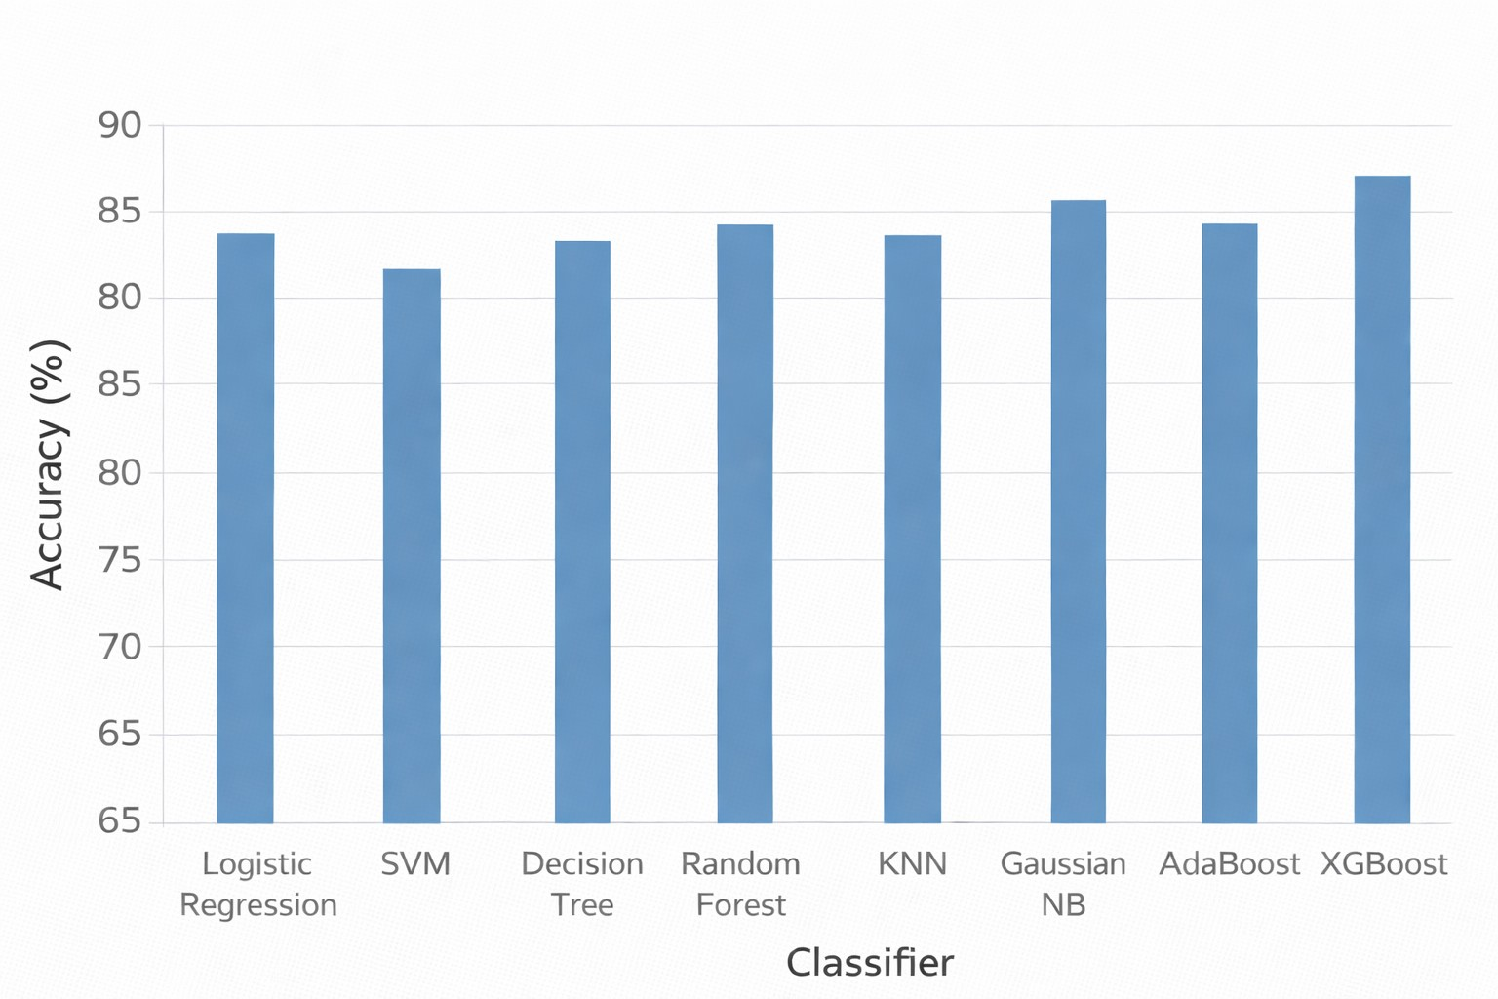

Fig. 1. Performance Comparison of Classifiers
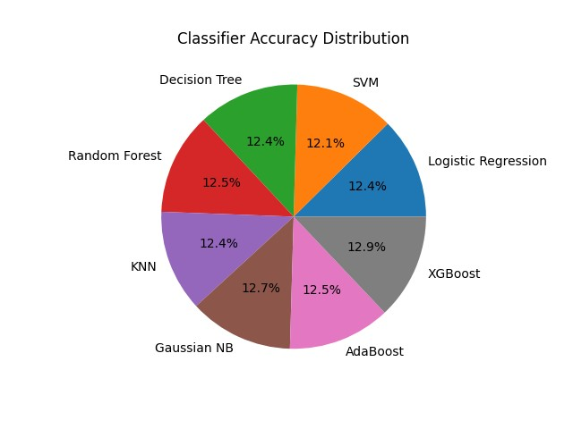

Fig. 2. Accuracy Distribution of Machine Learning Classifiers
survival rates and reducing the complexity of treatment. In this study, a prediction framework integrating PSO-based feature selection was evaluated using the Cervical Cancer Risk Factors dataset obtained from the UCI Machine Learning Repository.
Several classification techniques, including Logistic Regression, Support Vector Machine, Decision Tree, Random Forest, K-Nearest Neighbors, Gaussian Naive Bayes, AdaBoost, and XGBoost, were implemented and compared. The experimental analysis showed that ensemble-based approaches, particularly Random Forest, provided superior results in terms of accuracy, precision, recall, and Matthews Correlation Coefficient. The incorporation of PSO contributed to improved generalization by selecting relevant features and minimizing overfitting, resulting in a more efficient and reliable prediction system.

VIII. FUTURE WORK
improvements may be made in the future, including: feature Deep learning models. item Implementation as a web-based clinical tool. item Testing on bigger actual hospital datasets.
The current paper was written based on the Cervical Cancer Risk Factors databank received in the UCI repository. This dataset has few samples and there is a class imbalance that can affect the model results. The research can be further developed in future with larger and real time clinical data sets being used on hospitals and diagnostic centers to verify the proposed framework. The process of testing the system on various groups of patients would assist in determining how stable and applicable it can be to various populations.
This can be improved further by venturing into more sophisticated modeling techniques. Neural network based methods and hybrid ensemble models can be considered to assess whether they bring some extra benefit on the predictive level. Such techniques combined with appropriate optimization algorithms have the potential to enhance the representation of features and the accuracy of classification.
Along with that, other optimization algorithms like Genetic
Algorithm (GA), Ant Colony Optimization (ACO), and Grey Wolf Optimization (GWO) can be compared to PSO to determine the effectiveness of each in selecting the relevant features of medical data. The convergence behaviour and quality of solution could be improved by a comparative or hybrid optimization framework.

REFERENCES
- K. Kourou, T. Exarchos, K. Exarchos, M. Karamouzis, and D. Fotiadis, “Machine learning applications in cancer prognosis and prediction,” Computational and Structural Biotechnology Journal, vol. 13, pp. 8– 17, 2015.
- I. Guyon and A. Elisseeff, “An introduction to variable and feature selection,” Journal of Machine Learning Research, vol. 3, pp. 1157– 1182, 2003.
- J. Han, M. Kamber, and J. Pei, Data Mining: Concepts and Techniques. Morgan Kaufmann, 2011.
- J. Kennedy and R. Eberhart, “Particle swarm optimization,” in Proc. IEEE Int. Conf. Neural Networks, 1995, pp. 1942–1948.
- H. L. Santos, P. M. Rodrigues, and J. P. Papa, “Feature selection using particle swarm optimization for cervical cancer detection,” Expert Systems with Applications, vol. 42, no. 4, pp. 2519–2528, 2015.
- S. Fernandes, J. S. Cardoso, and J. Fernandes, “Transfer learning with partial observability applied to cervical cancer screening,” in Proc. Iberian Conf. Pattern Recognition and Image Analysis, 2017, pp. 243– 250.
- L. Breiman, “Random forests,” Machine Learning, vol. 45, no. 1, pp. 5–32, 2001.
- Y. Freund and R. E. Schapire, “A decision-theoretic generalization of on-line learning and an application to boosting,” Journal of Computer and System Sciences, vol. 55, no. 1, pp. 119–139, 1997.
- N. Friedman, D. Geiger, and M. Goldszmidt, “Bayesian network classifiers,” Machine Learning, vol. 29, no. 2-3, pp. 131–163, 1997.
- T. Chen and C. Guestrin, “Xgboost: A scalable tree boosting system,” in Proc. ACM SIGKDD, 2016, pp. 785–794.
- M. Lichman, “Uci machine learning repository,” 2013, [Online]. Available: http://archive.ics.uci.edu/ml.
- C. Cortes and V. Vapnik, “Support-vector networks,” Machine Learning, vol. 20, no. 3, pp. 273–297, 1995.
- D. Dua and C. Graff, “Uci machine learning repository,” 2019, university of California, Irvine.
- T. Hastie, R. Tibshirani, and J. Friedman, The Elements of Statistical Learning. New York: Springer, 2009.
- S. S. Haykin, Neural Networks and Learning Machines. New York: Prentice Hall, 2009.
- F. Pedregosa et al., “Scikit-learn: Machine learning in python,” Journal of Machine Learning Research, vol. 12, pp. 2825–2830, 2011.
- A. Liaw and M. Wiener, “Classification and regression by randomforest,” R News, vol. 2, no. 3, pp. 18–22, 2002.
- J. Quinlan, “Induction of decision trees,” Machine Learning, vol. 1, no. 1, pp. 81–106, 1986.

